**Brooklyn torah gazette**

**For parshas va’eschanan 5781**

Volume 5, Issue 49 (Whole Number 249) 15 Menachem Av 5781/ July 24, 2021

**Printed L’illuy nishmas Nechama bas R’ Noach, a”h**

For a free subscription, please forward your request to [***keren18@juno.com***](mailto:keren18@juno.com)

**Rabbi Berel Wein on**

**Parshat Va-Etchanan**

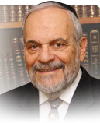

Although our teacher Moshe figuratively tears down the gates of Heaven with his prayers and supplications to be allowed to enter the land of Israel, his wish is not granted. Over the centuries, the commentators have offered various explanations as to why Heaven, so to speak, remains so adamant in refusing his request and prayer.

Even though many great and noble insights have been advanced to rationalize and explain this refusal of the prayers by Moshe, the question itself remains a vexing one, even thousands of years later.

The simplest and, perhaps, least satisfying answer to the problem is simply that we can never understand or fathom the judgments and decisions of Heaven. The mortal mind can never cross the line of eternity and will always be left with questions and difficulties. All of this is encompassed in the words of G-d: "No human being while alive can fathom or see Me".

Naturally, we are greatly frustrated by our inability to deal with eternity on a rational basis. We are frustrated by the realization of our limitations, whether they be physical, mental, spiritual, or even mundane. The aptitude to live and function within the limitations of one's own shortcomings is a great talent, and, unfortunately, there are many who do not possess it, and are constantly unhappy, disappointed, frustrated, pessimistic and morose.

All the utopian ideas and legislation currently being promoted in much of the Western world is simply an outlet for the disappointment that is felt when one realizes that society is not perfect, and that life usually is messy.

Moshe is told by Heaven that he should no longer pursue this course of prayer. He is to give up on his lifelong dream and accept the will of Heaven, even though he may not understand or agree with the decision that is being rendered. This becomes part of the matrix of the greatness of Moshe, in that he does accept this judgment against him, and we do not find him pursuing the matter any longer.

In his closing words to the Jewish people, Moshe will refer again to the fact that he will not lead them into the land of Israel, and that he will die and be buried in the land of Moab. But these statements are not made in bitterness or in complaint, but simply in recognition of the truth of the situation that faces him and the Jewish people.

Judaism is a religion of optimism, opportunity, and multiple choices, but contains within it a certain degree of fatalism – an understanding that the will of Heaven will not be thwarted, no matter what, and no matter how mysterious it may appear to an ordinarily mortal.

In Yiddish, this streak of fatalism is expressed in the word ‘bashert’*.* After all our attempts and actions have taken place, there still is this element that governs the outcome after all our efforts and seeming accomplishments. Such is the relationship of the created towards the Creator.

*Reprinted from the current website of rabbiwein.com*

**Parshas Veeschanan**

**The Middah of Rachamim**

**By Rabbi Bentzion Shafier**

**Founder of TheSmuz.com**

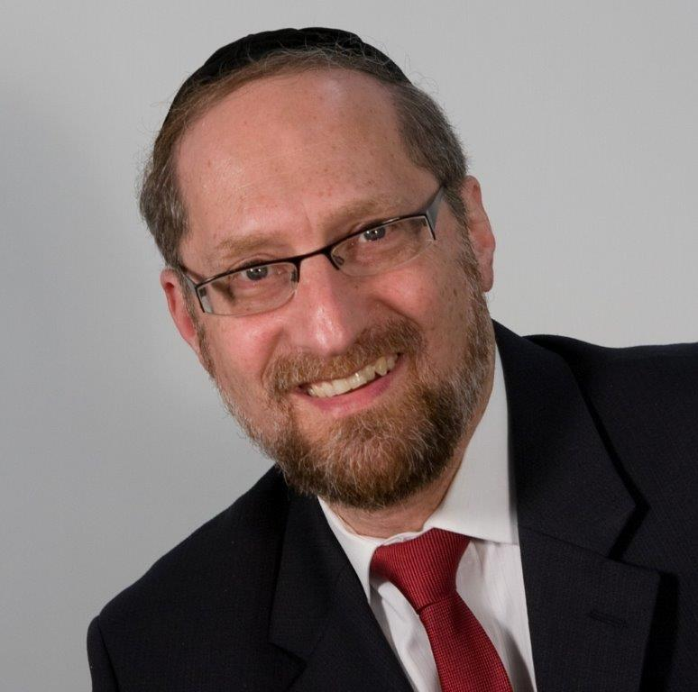

“*And pays back His enemies in their lifetime to destroy them*.” — Devarim 7:10

Rashi explains this posuk to mean that HASHEM pays back His enemies in this world so that there will be nothing owing to them in the World to Come, and then they can be destroyed.

The Rishonim tell us that one of the worst punishments a person can possibly suffer is to be paid back his reward in this world. Since our stay on this planet is so fleeting, if a person is paid the reward for his good deeds in this world, rather than in the World to Come, it is to his eternal misfortune, and is something that HASHEM will only do in retribution for wickedness.

This concept is difficult to understand. If this person is an **enemy** of HASHEM, why does HASHEM have to pay him back any reward at all, whether in this world or the Next? Why not simply destroy him?

To better understand this question, it will be helpful to focus our perspective.

**HASHEM Owes Us Nothing**

One of the manifestations of the immature person is a sense of entitlement. I am entitled to every benefit under the sun. I am entitled to life, health, and well-being. That is a given; that is the starting point. It’s all coming to me. And even if I grant that you have done something for me, what have you done for me lately? This attitude of entitlement strains many relationships, and is one of the most difficult parts of our serving HASHEM.

The Chovos Ha’Levavos explains that one of the realities of life is that a person isn’t entitled to anything. A person has to earn what he enjoys. We are the recipients of much good, not because we are entitled, not because anything is coming to us, but because HASHEM gives freely. HASHEM owes us nothing.

In reality, we are deeply indebted to HASHEM for everything that He does for us. If a person ever wanted to enter into judgment with HASHEM, comparing what HASHEM has given to him versus what he has given back, even the greatest tzaddik would fall woefully short and would have no reward waiting for him. However, as long as a person lives in accordance with the Torah, then what he receives in this world remains a gift, free to him without expectation of anything in return, and his reward remains intact in the World to Come.

Therefore, this question is powerful. If the Torah describes someone as an enemy of HASHEM, then HASHEM should simply act with strict justice, charge him for all he received in this world, and there would be no reward left. Why does HASHEM have to bother even paying him back with reward in this world?

**Why Did HASHEM Create this World?**

The answer to this question lies in understanding why HASHEM created this world.

The first most basic understanding that a person must come to if he wants to relate to HASHEM is that HASHEM lacks nothing. HASHEM is complete. When HASHEM created this world, it wasn’t for Him. It was for us. It was to give of His good to others. We are the recipients of that good. When HASHEM put us on the planet, it was so that we could earn our reward in the World to Come – the ultimate good for man. There we can enjoy HASHEM’s presence, there we can bask in His glory, and there we can enjoy the ultimate happiness that man can find. There is nothing in it for HASHEM. HASHEM is the Giver.

**What Happens When Man Veers Off Course?**

HASHEM also recognized that man will likely veer of course during his lifetime. According to strict judgment, man should then immediately lose his lease on life. The King of Kings created you and told you not to do something, but you had the audacity to violate His will! The punishment should be immediate and severe. However, man will inevitably sin, so the world cannot survive strict judgment. Therefore, HASHEM created the world with the system of rachamim. Now when man fails, the middah of rachamim calls out to forgive him and overlook what he has done. According to strict judgment, of course, he is completely guilty. But rachamim says, “There were mitigating factors that influenced him – environmental, social, and personal factors.” And so, HASHEM has mercy.

This seems to be the answer to the question. The attribute of mercy is so powerful that it comes into play even with someone whom the Torah calls an enemy of HASHEM and who deserves to be eliminated. The middah still calls out in his defense. For that reason, if it could be, HASHEM feels obligated to at least pay back this wicked person in this world, as if to say, “Pay him back for whatever good he did so that I can be rid of him.”

**What Right Do I Have to Ask HASHEM for Anything**

This concept has great relevance in our lives. Many times a person may feel, “What right do I have to ask HASHEM for help? After everything that HASHEM has showered upon me, do I serve Him as I should? Most of the time, I don’t even feel grateful for what was given to me. How can I now have the audacity to ask HASHEM to intervene on my behalf?”

The answer to this dilemma can be found by asking one revealing question: **Before I was created, what did I do to merit being created?**

By definition, the answer is nothing. I didn’t exist; therefore, I couldn’t merit anything. Once I come to grips with that concept, I now have a starting point to understand my relationship with HASHEM.

I am the recipient of good, not because I am entitled, not because it is coming to me, but because HASHEM gives freely, without holding back and without expecting anything in return.

As I stand here today, I may have sullied myself, and I am therefore not deserving of anything from HASHEM, but very little has changed since my birth. Before I was created, I wasn’t worthy of anything. Yet HASHEM created me because He is giving. So too now, I am surely not deserving, but I can trust in the kindliness of HASHEM to have mercy and provide for me. Much like a rebellious child who knows that his father will always love him and that he can always turn to him, so too we are called children of HASHEM. We can always rely on that mercy.

For that reason, provided that we follow the Torah’s system and sincerely attempt to serve HASHEM and improve ourselves, we can always rely on HASHEM, even if it is true that we aren’t deserving.

*Reprinted from this week’s website of Theshmuz.com.*

# Rav Avigdor Miller on

# Sinas Chinam: Rebelling Against Hashem



**QUESTION:** **How can you explain that sinas chinam is as bad as avodah zara, giluy arayos and shfichas damim? What makes hatred of a fellow Jew so bad that it’s put into the same category as those terrible aveiros?**

**ANSWER:** Sinas chinam in a certain sense is the cause for everything else.

One of the Rishonim – I think it’s the Chovos Halvovos or Rabbeinu Saadya Gaon – said that one of the causes for a lack of emunah is the sinah towards ovdei Hashem.  When people have an anger on their fellow Jews, it causes them to be not only displeased with them, but they’re displeased with the people in general; and even their ideals become to him mufrach. He doesn’t even like their ideals either.

I once heard the president of Agudas HaRabanim speaking fifty years ago.  He said, “When people talk against rabbonim,” he said, “They don’t have any claim against them.  It’s really a sinah to Torah.  That’s what it really is.” When people have a sinah to frum Jews, they are soinim of Hashem.  I’ll explain that.    
  
 Hashem says to us, “I love you.”   He loves the Am Yisroel! Wherever you look in the Torah in the Neviim and Kesuvim, Hashem says, “I love them!”  So how could a person hate whom Hashem loves? So Hashem says, “If you hate My children, then you hate Me too!” And the Mesilas Yesharim says, Hashem only loves someone who loves His children. You have to love his children.

So therefore, if a person has a sinah to a fellow Jew, he must know right away he’s a soineh Hashem because that Jew represents Hashem.

“Oh,” he says, “But other Jews I don’t hate – only him.”

It makes no difference.  He is one of them.  He represents those who Hakodosh Boruch Hu says about them, “That’s My people.”  And therefore, Anybody who curses a fellow Jew – he doesn’t have to curse; even if in his heart he’d like to see a misfortune come on his fellow Jew; a sameyach l’aid lo yinakeh!  Even though it’s just in his heart, he’s not doing anything; he’s just waiting to see bad news from a fellow Jew, he should know that Hashem is already against him.

Now that’s the beginning of other things.  Many people went out l’tarbus ra’ah as a result of machlokes with Jews.  It could be sometimes, chalilah, it led to shfichas damim too.  And it’s avodah zara because it means minus.  If you can’t find in your heart to love the Jew who serves Hashem – after all he’s a frum Jew; his house is a kosher place and his children are learning Torah – so can you hate a Jew like that?  Just because of some personal thing that he did to you? But he’s from the Am Yisroel! Hashem loves him! It means that Hashem is far from your mind. And therefore, that’s the beginning of avodah zara. Now although it’s not the act itself, but it certainly is chas v’shalom a makor for such acts.

*Reprinted from the July 15, 2021 email of Toras Avigdor. Adapted from Tape #E-65.*

**The Jew’s Ability to Utilize the Study of Torah and thereby Become a Truly G-dly Person**

**From the Talks of the Lubavitcher Rebbe**

**Rabbi Menachem Mendel Schneerson, Zt”l**

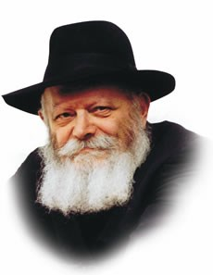

This week's Torah portion, Va'etchanan, speaks about the mitzva of learning Torah, and contains the verse, "And You shall teach them to your children, and speak of them..."

In general, the mitzva of learning Torah consists of two separate commandments: The obligation each person has to learn Torah, and the obligation to teach Torah to others, especially one's children.

Although a person might naturally think that the mitzva of learning Torah oneself takes precedence over that of teaching others, we find that the opposite is true. Both Maimonides' writings and the Code of Jewish Law begin the section on the laws covering the learning of Torah with the duty each parent has to teach his children. Why is this the case? And furthermore, how can a person teach others before he himself is well-versed enough in the subject matter?

We learn from the emphasis on teaching children the proper approach we must have when we begin to learn Torah. To understand this, let us examine the difference between Torah learning and the performance of mitzvot.

When a Jew does a mitzva he effects a change in the physical world, elevating and making holy the physical objects he uses in the mitzva's performance. The practical performance of the mitzva is therefore more important than the intentions of the person doing the deed, for the action itself serves to bring spiritual illumination into the world.

Torah learning, on the other hand, serves to refine and elevate the individual. When a Jew studies Torah his intellect becomes united with the G-dly wisdom contained in the Torah and causes him to be a G-dly person whose thoughts are those of holiness. The essence of learning Torah is therefore the humility and self-nullification one must feel before even approaching it to learn. In order to learn Torah properly one must have the sincere desire to understand G-d's wisdom without ulterior motives.

Before a Jew learns Torah he must subjugate his own ego and ask, what does the Torah itself want from me? Without this prerequisite, say our Sages, Torah learning can even be detrimental and becomes a "poisonous drug."

Emphasizing the duty to teach our children before we ourselves learn the Torah stresses that our goal is not merely the acquisition of knowledge, for the mind of a young child cannot possibly grasp the greatness of what he is learning. Our goal is to emulate the child's purity and innocence with regard to how he learns the Divinely written words. We must approach the Torah in the same way, and not try to "fit" what we learn into our view of the world. All of us, no matter how old we are, are like children to our Father in Heaven.

*Reprinted from the 5756/1996 Parshat Va’eschanan edition of L’Chaim Weekly. Adapted from the works of the Lubavitcher Rebbe.*

**Rabbi Who Helped Transform Jewish Life in South Africa Steps into New Role**

**By Yosef Kaufmann**

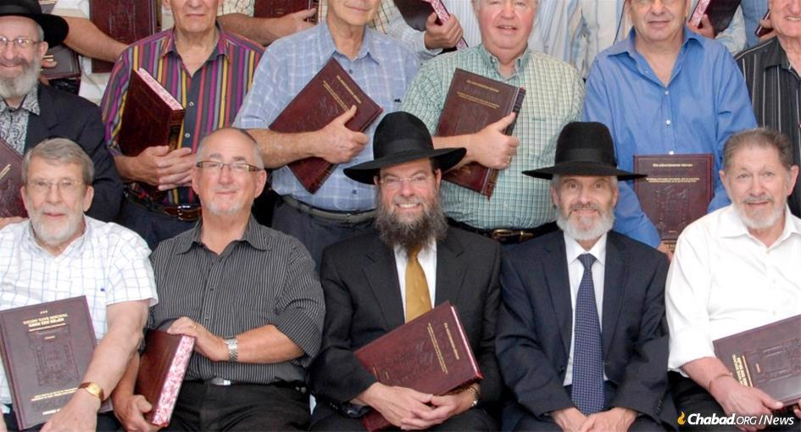

**Rabbi Yossy Goldman, center, at a ceremony celebrating the completion of a book of the Talmud with guest speaker Rabbi Dr. Akiva Tatz to his right.**

For more than 30 years, people coming to pray in Johannesburg’s largest synagogue have been greeted by a familiar sight: [Rabbi Yossy Goldman](https://www.chabad.org/search/keyword_cdo/kid/1351/jewish/Yossy-Goldman.htm) sitting by his dais, ready to lead the service. Be it a Friday night, Shabbat day or Yom Kippur. For bar mitzvahs and weddings, brit milahs and funerals, Goldman has been there. Inspiring, teaching, comforting and uplifting his community.

The rabbi, together with his wife, Rochel, have transformed Sydenham Shul, in the words of the late [Rabbi Lord Jonathan Sacks](https://www.chabad.org/library/article_cdo/aid/4913164/jewish/Rabbi-Lord-Jonathan-Sacks.htm), into “one of the great synagogues of the English-speaking world,” while helping steer South Africa’s Jewish community into the post-Apartheid era.

From radio shows to Mishnah and Talmud classes, teaching everything from aleph bet to philosophy, Yiddish classes and how to bake challah, the Goldmans have dedicated their lives and given their heart and souls to spreading Judaism throughout their community.

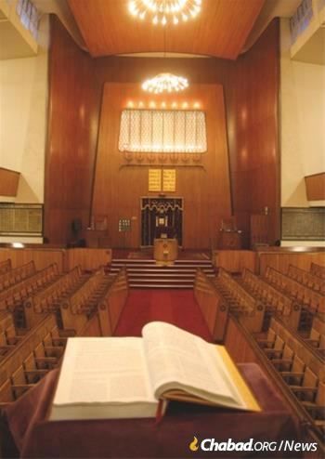

**The main sanctuary of the Sydenham Shul in Johannesburg**

For the rabbi, a self-described “marketer” of Torah and Judaism, after 34 years of leading his community, the time has come to pass on the mantle of leadership to Rabbi Yehuda Stern, who has been the synagogue’s associate rabbi for the past 14 years. But this is not the end of the journey, notes Goldman. It is a transition, a turning of the page to a new chapter.

“While I have reinvented myself more than once over the years, a new generation now looms,” he said. “If we are to grow the *shul* and attract younger families, we will need new approaches, fresh ideas, and indeed, new blood.”

The announcement of the transition has brought with it an outpouring of praise for the Goldmans. “I’ve been involved with Sydenham Shul all my life,” said Ingrid Seeff. “As a couple, the Goldmans have inspired me and made an indelible impression on my family’s lives. And we will always be so grateful to them for their friendship and leadership.”

“I met Rabbi Goldman in 1986, when I was a member of the Shul Council,” says Judge Phillip Boruchowitz, a former member of the South African High Court. “I had previously interacted with the rabbis of the *shul*, and each had their own ‘brand.’ But there was nothing to beat the special Goldman brand. Together with [Rochel](https://www.chabad.org/parshah/article_cdo/aid/3514793/jewish/Diary-of-Rachel.htm" \o "Diary of Rachel), he introduced an energy and vibrancy that previously did not exist. They were able in a short amount of time to capture the imagination of young and older members alike. They introduced a new and refreshing way of looking at Judaism through the eyes of Chassidic teaching and especially the teachings of [the Lubavitcher Rebbe](http://www.therebbe.org/) [Rabbi Menachem M. Schneerson, of righteous memory].”

**The Fall of Apartheid and Resurgence of Jewish Life**

When Judge Boruchowitz first met the Goldmans, in 1986, they had already been spreading the depth and joy of Chassidic teachings for a decade. In an article on Jewish life in South Africa over the past 50 years, [“How the Rebbe Saved South African Jewry”](https://www.chabad.org/therebbe/article_cdo/aid/4787128/jewish/How-the-Rebbe-Saved-South-African-Jewry.htm), Goldman describes his arrival in Johannesburg in 1976, only three months before the Soweto uprising that would become a major milestone in the eventual fall of the racist apartheid regime:

“The country was in turmoil. Masses of white families were leaving in droves. People here told us they couldn’t understand how a young couple with two small children would move to South Africa when everyone else was leaving. The park benches had signs stating, “Whites Only.” There were separate buses, separate waiting lines in the post office, separate counters in the liquor stores. And there was palpable anxiety in the heart of virtually every white South African.

In the 70s and 80s there were not many South African-born rabbis here. With the political situation so volatile, British and American rabbis were no longer considering positions here, and even rabbis who were already here were leaving. So many families were emigrating that the community was being decimated. What would become of all the schools, shuls, and proud institutional infrastructure?

During this period of uncertainty, the Rebbe sent his rabbinical students to serve this community as his emissaries, giving South Africa a massive vote of confidence.



**Rabbi Yossy and Rochel Goldman with Nelson Mandela**

In 1979, with its small school in Yeoville now bursting at the seams, the Lubavitch Foundation purchased a large tract of land in the prime northern suburbs of Johannesburg. Property prices were down; it was an unbelievably good deal. The [Torah](https://www.chabad.org/library/article_cdo/aid/2126/jewish/What-Is-the-Torah.htm) Academy would now be able to expand and unlock much exciting potential.

But the lay leaders of this community, namely the Jewish Board of Deputies, Zionist Federation, Board of Jewish Education, Israel United Appeal and United Communal Fund all attempted to prevail upon us that we should abandon our “reckless empire building.” South African Jewry was “in decline,” they stressed. There wouldn’t be enough children or sufficient financial resources in the community to support another stream of Jewish education, they argued. When we respectfully disagreed, they wrote a letter to the Rebbe, signed by the chairmen of theBoard and the Federation, asking him to curb his errant emissaries.

The Rebbe [responded with a long letter](https://www.chabad.org/therebbe/letters/default_cdo/aid/1921274/jewish/Projecting-the-Future-of-South-African-Jewry.htm) encouraging those lay leaders to do their utmost to reverse the very decline they had referred to. He praised our strong, warmly traditional Jewish community and also highlighted its proud relationship with Israel. He further pointed out that Jewish communities the world over played an important partner role with Israel in influencing their local governments to maintain positive international relations with the Jewish state. We had to do our part, too.

**'The Rebbe Loves Every Jew'**

In a recent interview [with Chabad.org](http://www.chabad.org/news), Goldman marvelled at the Rebbe’s *[ahavat Yisrael](https://www.chabad.org/library/article_cdo/aid/696977/jewish/Love-Your-Fellow.htm" \o "Love Your Fellow)*. “It was at this time, after 10 years of outreach, that I was approached by the Sydenham Shul Chairman to take over as the rabbi,” said Goldman. “The former rabbi of Sydenham Shul had just announced that he was emigrating. I wrote a letter to the Rebbe explaining the situation.”

“I was very invested in the Chabad activities,” the rabbi continued. “I had established the very first Chabad House in the country, and then the Torah Academy Shul, and I was directing all the outreach programs of [Chabad](https://www.chabad.org/library/article_cdo/aid/244369/jewish/About-Chabad-Lubavitch.htm). The Rebbe told me to first consult with the leaders of the Chabad community in Johannesburg. We had a meeting, and it was unanimous. I wrote back to the Rebbe telling him the decision was unanimous, and I received a beautiful *Brachah* from the Rebbe to accept the position at the Sydenham Shul.”

“The Rebbe loves every Jew, “said Goldman. “If Chabad was just a corporation, they would never let one of their top guys leave the organization. Here’s the head of the movement encouraging one of its successful leaders to leave the movement for another organization. But the Rebbe was concerned for every Jew and every shul regardless. Sydenham Shul is not a Chabad shul, and at the time, it was unheard of for the big mainstream shuls here to hire a Lubavitcher. Today, thank G‑d, it is quite common practice in South Africa.”

**A Deep Impact on the Nation’s Jewish Community**

Over the following decades, the Goldmans had a deep impact on the South African Jewish community. The Rabbi was elected Chairman of the South African Rabbinical Association and presided over meetings with the full spectrum of the Rabbinate and doing much for local rabbis over a 12-year period. His influence reached across the country way beyond Sydenham Shul. He continues today as the Association’s President.

Adrian Gore, CEO of the Discovery Group, a multinational health and financial-services organization, said, “He has built an incredibly powerful community that is not just powerful in and of itself, but has had a significant impact on the Jewish community in the entire country, and therefore the country itself. Rabbi Goldman is an incredibly powerful and important leader. I find him so effective in making an impact. He’s someone who’s accessible, he is humorous, and has a light intimate touch. But don't be fooled by that; he’s someone of considerable gravitas, a very deeply learned man. And that paradox makes him such a powerful and effective leader. His legacy is going to be incredibly strong.”

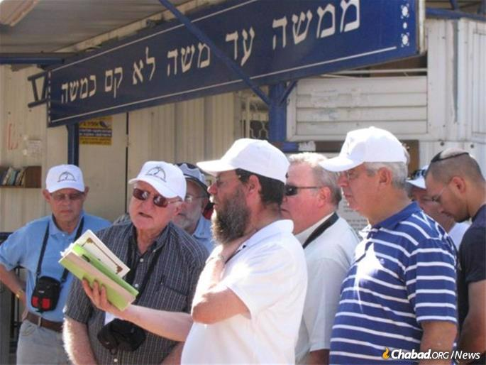

**Learning Rambam at his tomb in Tiberias on a Sydenham Shul tour of Israel in 2011.**

The new leadership is taking the helm with the Goldmans’ encouragement and support. Rabbi [Yehuda](https://www.chabad.org/library/article_cdo/aid/112513/jewish/Judah.htm) and Estee Stern were brought over from Melbourne, Australia, 14 years ago by Sydenham Shul as associate rabbi to lead the “Shtibl,” the alternative *minyan*. Immediately, the Sterns formed a powerful connection and chemistry with both the Goldmans and the Sydenham family. The many initiatives and projects that they started have built the Shtibl into a blossoming family and have brought back many second- and third-generation members that were drifting away. And they developed a Young Adult following, which now can help build an exciting future for the congregation.



**Rabbi Yehuda and Estee Stern (Photo: Hylton Goldstein)**

Stanley Seeff, president of Sydenham Shul, said, “Rabbi Stern has been appointed rabbi of Sydenham Shul and now assumes the everyday responsibilities required of our spiritual leader. Rabbi Goldman, supported by the Shul Council, believes that Rabbi Stern has the talent, ability and energy to continue to build our special congregation. Rabbi Yehuda and Estee have endeared themselves to our community and have been the driving force behind so many ground-breaking and innovative initiatives. We are well-positioned for new development and growth in the years ahead.”

“We all have such high hopes for Rabbi and Rebbetzin Stern,” said South Africa’s Chief Rabbi Warren Goldstein. “We have seen them over these years serve the community in so many different ways. With their warmth and kindness, with their brilliance in teaching, their learning and compassion. The way that they understand people and the way that they innovate, and are always thinking of new opportunities to grow the shul. We’ve seen them do it in the Shtibl and now we know they are going to do it for the entire congregation, and that is something that is so exciting for South African Jewry—to see talented visionary leaders coming to the fore to make a difference.”

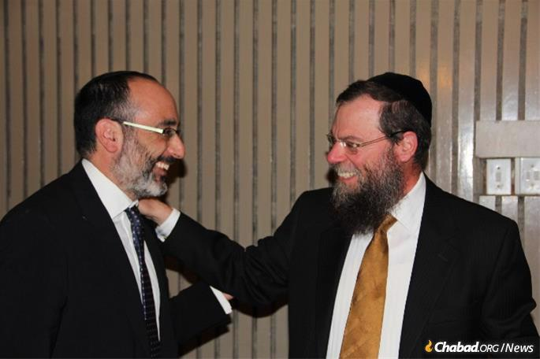

**Rabbi Goldman With South Africa’s Chief Rabbi Warren Goldstein**

As Goldman moves into an emeritus role, he is determined for his good works to continue.

“Let me assure you that I am not retiring to the coast to spend my life going fishing,” he said. “I vividly recall my own great teacher and mentor—the Rebbe, of righteous memory—speaking at his own 70th birthday *farbrengen* saying that people have been telling him to slow down now, take it easy or go on vacation. Instead, the Rebbe called for the establishment of at least 71 new institutions that year! The word ‘retirement’ simply did not appear in the Rebbe’s lexicon. Life must always be purposeful, productive and meaningful, he believed.”

“We all have a responsibility to keep making the world a better place in whichever way each of us is able,” continued Goldman. “Indeed, it is my intention to continue to work diligently and vigorously on new projects and to continue my mission for which the Rebbe sent us to South Africa. While we do hope to travel and be able to accept speaking invitations from around the world, we certainly do not intend, [G‑d](https://www.chabad.org/library/article_cdo/aid/433240/jewish/God.htm) forbid, to abandon Sydenham Shul, and all the wonderful people and families Rochel and I have developed such strong friendships and relationships with over the past decades. They are a very big and very precious part of our lives, and please G‑d, will continue to be so forever.”



**“We all have a responsibility to keep making the world a better place in whichever way each of us is able,” said Goldman. (Photo: Hylton Goldstein)**

*Reprinted from the July 15, 2021 email of Chabad.Org Magazine.*